**Week 1 Lab**

**Accessing Oracle RMAN and SQL Server Management Studio**

Our week for the term will be done in two different environments. You will need to install the most recent version of the SQL Server software, the SQL Server Management Studio (SSMS) and install the AdventureWorks sample schema. These steps are all outlined in the SQL Server Setup document contained in the Canvas container. For the Oracle work that you will be completing, each student is assigned a Virtual Machine (VM) that will be used for the term. For the technical information regarding the Oracle environment see the VM Setup document in the Canvas container. The VM has the Red Hat Linux operating system installed on it and has three Oracle 21c multitenant container databases installed; DB101, SPOCK, and RMAN (don’t confuse this RMAN database with the Oracle client RMAN utility, rman, which is used for backup and recovery tasks).

The Oracle portion of this week’s lab will be completed in the DB101 database. The SQL Server work will be done in your locally installed SQL Server installation.

The objective for this week’s work to understand and be able to execute access to your databases. For both platforms this is not necessarily intuitive, so we will walk through the process. Accessing an Oracle system is more steps to it, most of which needs to be repeated each time you log in to the server or create a new Linux shell.

Recovery Manager (RMAN) is an Oracle Database client utility that performs backup and recovery tasks on your databases and automates the administration of your backup strategies. It greatly simplifies backing up, restoring, and recovering database files.

The RMAN environment consists of the utilities and databases that play a role in backing up your data. At a minimum, the environment for RMAN must include the following components:

1. A Target Database
2. An Oracle Database to which RMAN is connected with the TARGET keyword. A target database is a database on which RMAN is performing backup and recovery operations. RMAN always maintains metadata about its operations on a database in the control file of the database. The RMAN metadata is known as the RMAN repository.
3. The RMAN client

The Oracle Backup and Recovery textbook contains information on these components. Ensure that you have read this material thoroughly and understand their functions.

The RMAN client tool is an Oracle database executable that interprets commands, directs server sessions to execute those commands, and records its activity in the target database control file. The RMAN executable is automatically installed with the database and is typically located in the same directory as the other database executables. For example, the RMAN client on Linux is located in $ORACLE_HOME/bin.

RMAN connections to a database are specified and authenticated in the same way as SQL*Plus connections to a database. The only difference is that RMAN connections to a target or auxiliary database require either the SYSDBA or SYSBACKUP privilege. Any user can be granted this privilege.

You connect to RMAN simply by typing in rman at the Linux command line interface. For example, at the command line prompt ($) type in rman. Keep in mind Linux is case sensitive. Typing RMAN and rman are not the same command.

# Section One: Connecting to RMAN

## Prelab setup

Logon to your Linux vm and setup your environment. Keep in mind for the commands in the labs, you do not type in the $ sign as part of the command. The $ sign is widely used in technical documentation to indicate you are running commands at the Linux operating system command prompt:

**$ export ORACLE_SID=db101**

**$ . profile.sh**

Verify your ORACLE_SID is set correctly:

**$ echo $ORACLE_SID**

**$ echo $PATH**

If your database is not started, then start it:

**$ sqlplus / as sysdba**

**SQL> startup;**

**SQL> exit;**

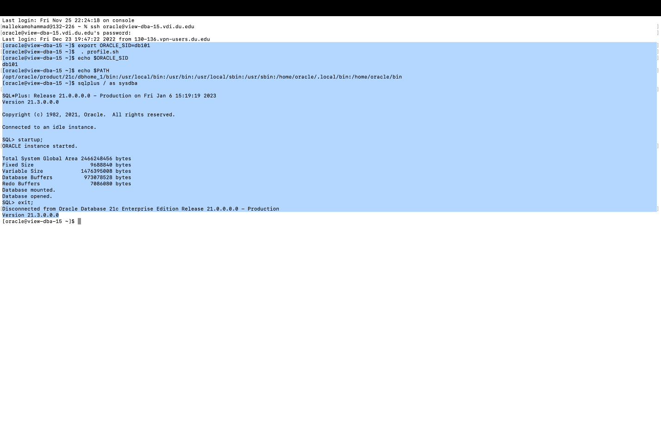

## 1. Start the Oracle RMAN client

**$ rman**

You should now be at the RMAN command prompt:

RMAN>

Exit from RMAN:

**RMAN> exit;**

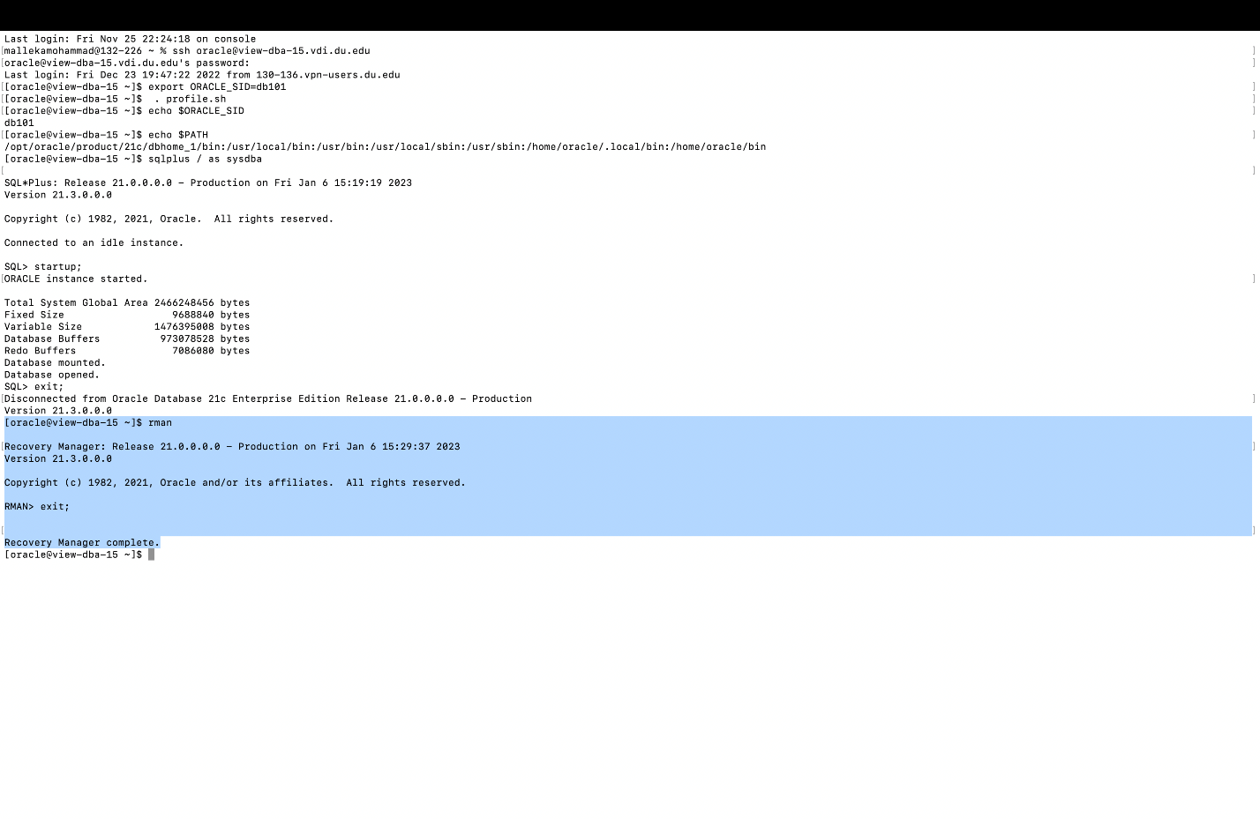

## 2. Connect to the target database from the operating system command prompt and verify the user connection information:

**$ rman target /**

**RMAN> select user from dual;**

**RMAN> exit;**

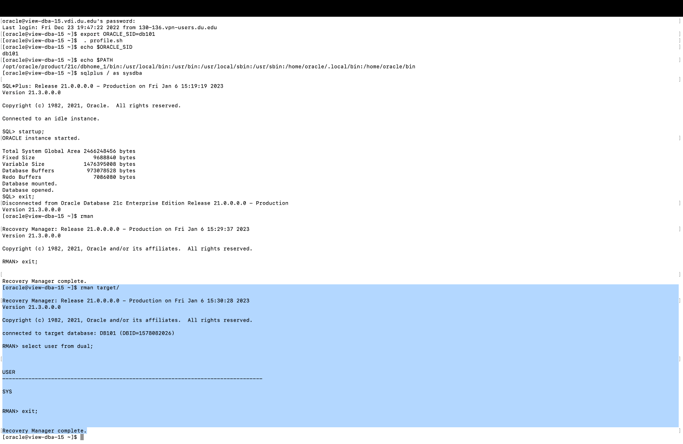

**Question: What user are you connected to RMAN as?**

I have connected to the user SYS.

## 3. Another method to connect to RMAN and your target database is as follows:

**$ rman**

**RMAN> connect target /**

**RMAN> exit;**

In practice, most Oracle DBAs do not use the above technique to connect to RMAN and the target database, mainly because it’s less typing to connect directly all on one line from the operating system command line as shown below:

**$ rman target /**

**RMAN> exit;**

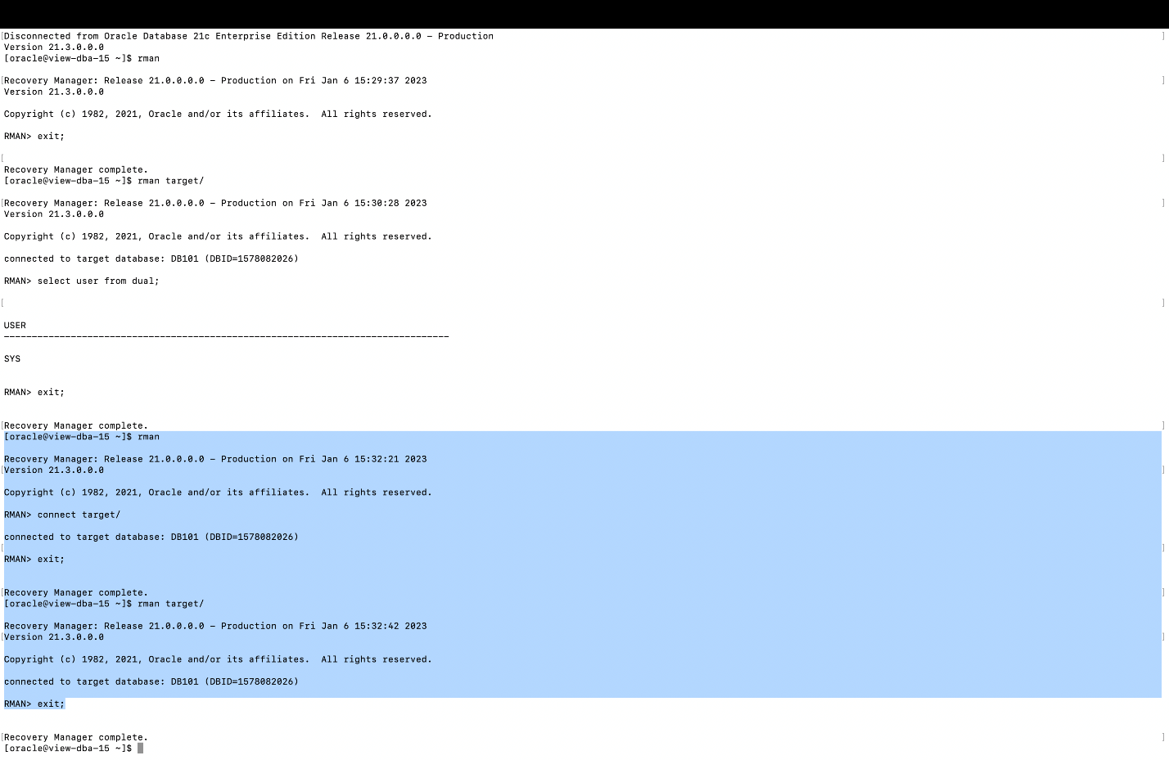

# Section Two: Running Basic RMAN Commands

The SHOW command displays current settings established with the CONFIGURE command. These parameters can be set here or in a script that runs the backup job.

**$ rman target /**

**RMAN> show all;**

## 1. What does the SHOW ALL command tell you about your current RMAN configuration?

The SHOW ALL command displays the current settings of all parameters that you can set with the CONFIGURE command. The output includes both parameters you have changed and parameters that are still set to the default. The configuration is displayed as the series of RMAN commands required to re-create the configuration.

## 2. If your Oracle database is noarchivelog mode, you cannot take an online (hot) backup. However, you can take an offline backup of a database in noarchivelog mode. Verify the log mode of your database:

**RMAN> select log_mode from v$database;**

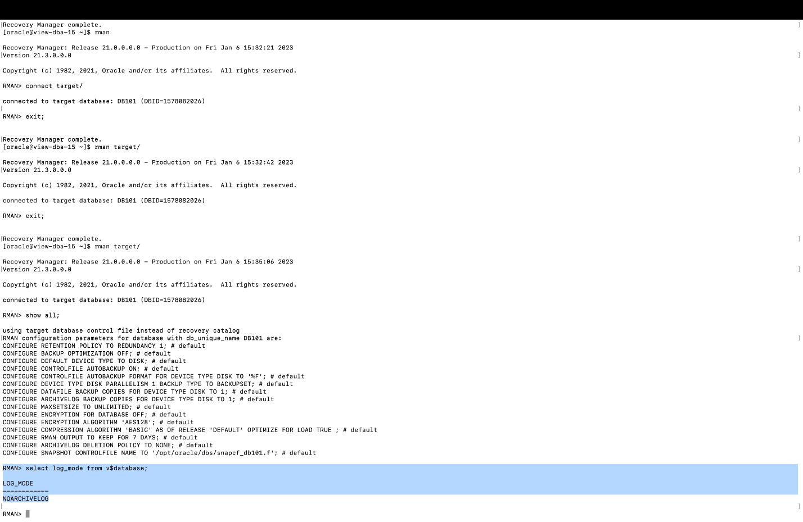

## 3. Take an offline (cold) backup. Your Oracle database must be offline and in mount mode to take an offline backup. Do the following to take an offline backup.

If your database is running, then shut it down first, and then start your database in mount mode:

**RMAN> SHUTDOWN IMMEDIATE;**

**RMAN> STARTUP MOUNT;**

**RMAN> BACKUP DATABASE;**

**RMAN> ALTER DATABASE OPEN;**

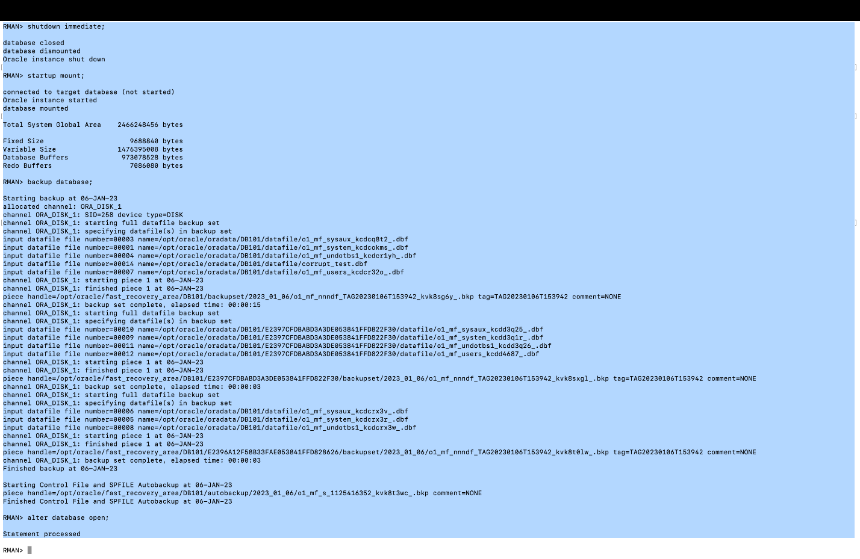

## 4. A common misconception is that an Oracle offline (cold) backup is better than an online (hot) backup). Here is the truth: *An Oracle online backup is as reliable, secure, and safe as an offline backup.*

**Having said that, under what circumstances would you take an offline backup?**

During the database is offline and not accessible to update.

## 5. LIST and REPORT. You can access metadata from the RMAN repository in several different ways. The RMAN LIST and REPORT commands provide extensive information about available backups and how they can be used to restore and recover your database.

List your database backup information:

**RMAN> list backup;**

[paste results, just a few lines is fine, don’t paste the entire contents of the list command]

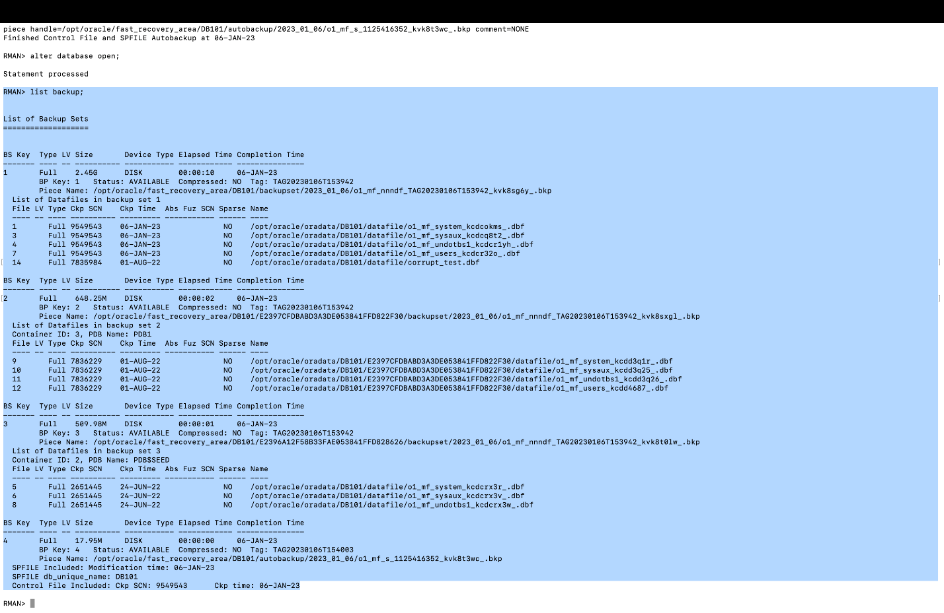

# Section Three: Accessing the SQL Server Management Studio (SSMS) for Backups

For the Oracle database backup and recovery processes we will be working from command line. There are several management tools that can be used to complete these tasks (Oracle Enterprise Manager - OEM, TOAD, which are two of the tools used frequently), but backup jobs are run from RMAN often from shell scripts.

In the case of SQL Server the SSMS is most often employed. You can run backup and recovery operations from the Windows command line interface, but this is not a common method so our work will focus on the SSMS methods.

## 1. Initialize SSMS and login.

As I am using Azure data studio for sql server I don’t have to install SSMS.

## 2. In the Object Explorer expand the Management folder.

I am using Azure data studio

## 3. Right click on the Maintenance Plans folder to bring up the New Maintenance Plan window.

I am using Azure data studio

NOTE: Depending on how your SQL Server installation was set up you may encounter the following error:

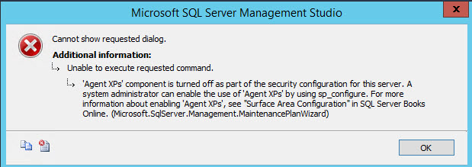

You will need to resolve this problem before you can bring up the New Maintenance Plan window or create new plans. Make sure that you resolve this problem before you submit this assignment. You will need to be able to create maintenance plans to complete later SQL Server assignments.

Access this [SQL Server FIX](https://blog.sqlauthority.com/2016/06/13/sql-server-fix-agent-xps-component-turned-off-part-security-configuration-server/) online document, and follow the steps outlined. If this fix is unsuccessful contact your course instructor to further troubleshooting.

Here’s the link to the website with the instructions on how to fix the above error, basically you have to start an agent:

https://blog.sqlauthority.com/2016/06/13/sql-server-fix-agent-xps-component-turned-off-part-security-configuration-server/

## Click OK and bring up a new maintenance plan.

I am using Azure data studio

## Cancel the maintenance plan. We will be creating maintenance plans in a later lab. You have accessed the interfaces that we will be using to complete backups. As you have seen Oracle and SQL Server are quite different from one another. Reflect on what your impressions are up to this point.

I am using Azure data studio

## 6. Create a new database, take a backup, and view the last backup date

### A) Create a new database named testdb

**Right click on Databases, then New Database, then Add**

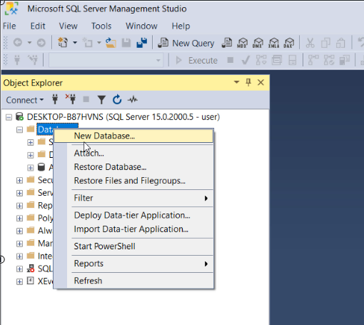

### B) Backup the newly added database

**Right click on the database name, then Tasks, then Back Up, then OK**

### C) Verify the new database was backed up:

**Right click on the database, then Properties**

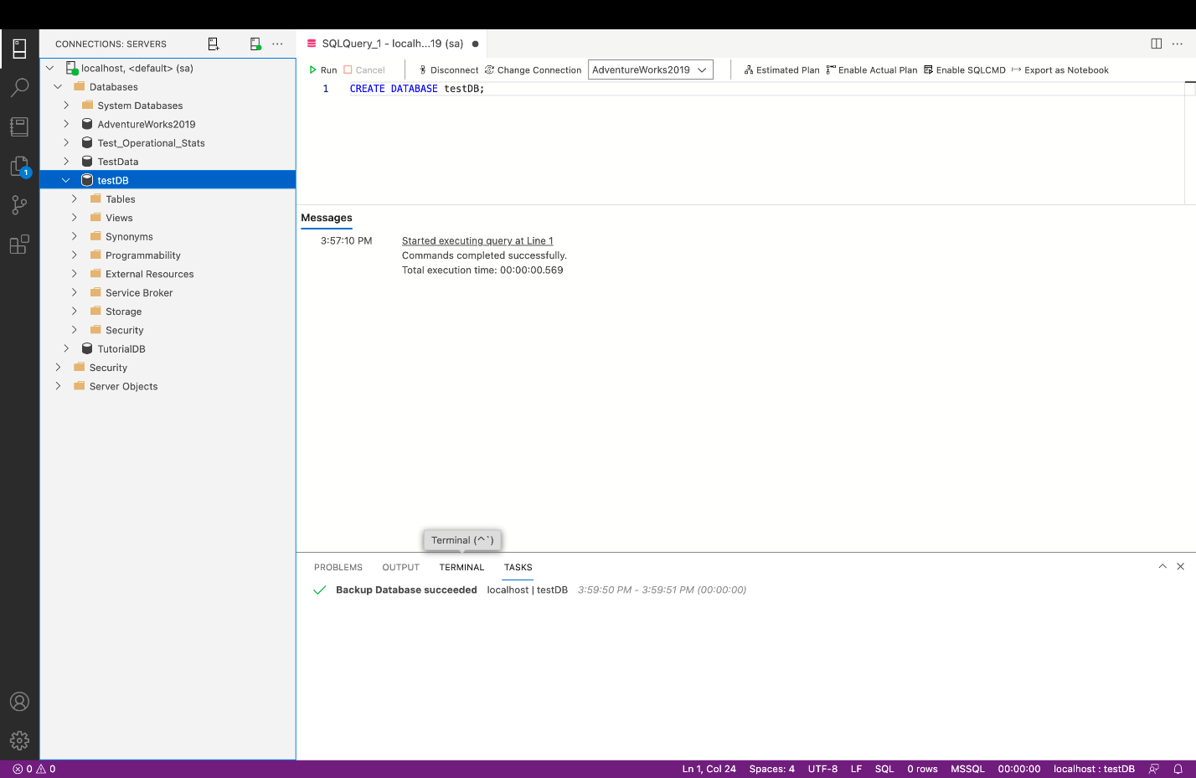

# Final Write-up

In this final write up you will need to reflect on what you learned during this course of this lab. (Use a few sentences and/or paragraphs to answer each question as appropriate)

## 1. What did you find difficult or easy?

As my installation were done before for the previous quarter it was very easy for me to understand.

## 2. What resources did you find useful/helpful?

Everything was been detailing explained that is very helpful.

## What do you wish you knew before?

Nothing, I am good.